**LEBANESE AMERICAN UNIVERSITY**

**USAID – HIGHER EDUCATION SCHOLARSHIP PROGRAM**

**HES - Volunteering Program Verification Form**

This form is to be used to document volunteering hours. If a student volunteers for multiple organizations, a separate form must be used for each organization. **This form must be turned in by the 28th of each month, the latest.**

I certify that the scholar Mirna Salem completed a total of 5 hours of service at InnovaThrive.

The hours were completed hours as per the below:

Hours # 2 (date) _2/12 – 6/12_ (initials of supervisor) __A.K.___

Hours # 1 (date) _9/12 – 13/12_ (initials of supervisor) __A.K.___

Hours # 1 date) _16/12 – 20/12 (initials of supervisor) __A.K.___

Hours # 1 date) _23/12 - 27/12 (initials of supervisor) __A.K.___

Brief description of the activities the scholar performed or participated in:

I conducted research on Blockchain for Secure Cross-Border Transactions in Finance, focusing on how blockchain technology can streamline international money transfers. My study explored key technologies, including smart contracts for automating cross-border payments and cryptocurrencies for instant international transfers.  
  
I examined practical applications, such as reducing transaction fees in remittances and implementing global blockchain-enabled payment systems to support small businesses. Supporting statistics showed that blockchain can reduce cross-border transaction fees by 25%.  
  
The research highlighted the advantages of blockchain in finance, such as greater efficiency in international transactions. However, it also addressed disadvantages, like regulatory uncertainties surrounding blockchain integration in financial systems.  
  
In terms of challenges, I investigated issues such as ensuring compatibility between blockchain solutions and traditional banking infrastructure. Finally, I proposed areas for future research, including utilizing blockchain for real-time, low-cost trade financing and expanding its reach to unbanked populations, thereby promoting financial inclusion.

Written feedback about the scholar’s performance:

Mirna exhibited strong research and problem-solving skills in analyzing blockchain for cross-border transactions, addressing challenges and proposing impactful financial innovations.

Please rate the overall performance of the scholar at your organization:

|  |  |  |  |
| --- | --- | --- | --- |
|  | Mastery (5) | Proficient (3) | Emerging (1) |
| **Problem solver** | X |  |  |
| **Engaged & Committed** | X |  |  |
| **Open-minded & multicultural** | X |  |  |

Signature

& stamp

__________________________

_

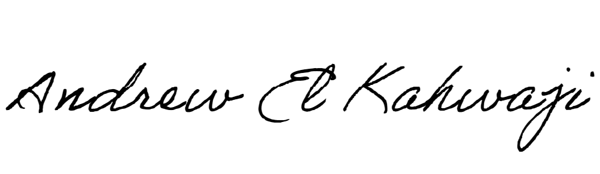

Printed Name _Andrew El Kahwaji_

Date __26/12/2024___

Email __andrew.lifesculptor.coo@gmail.com __

Phone __+961 71 914 378__